**Evaluating the Environmental impact of Mineral water Extraction**

* We are students of compute department of Vidya Pratishthan’s polytechnic college indapur. We visited a mineral water company.

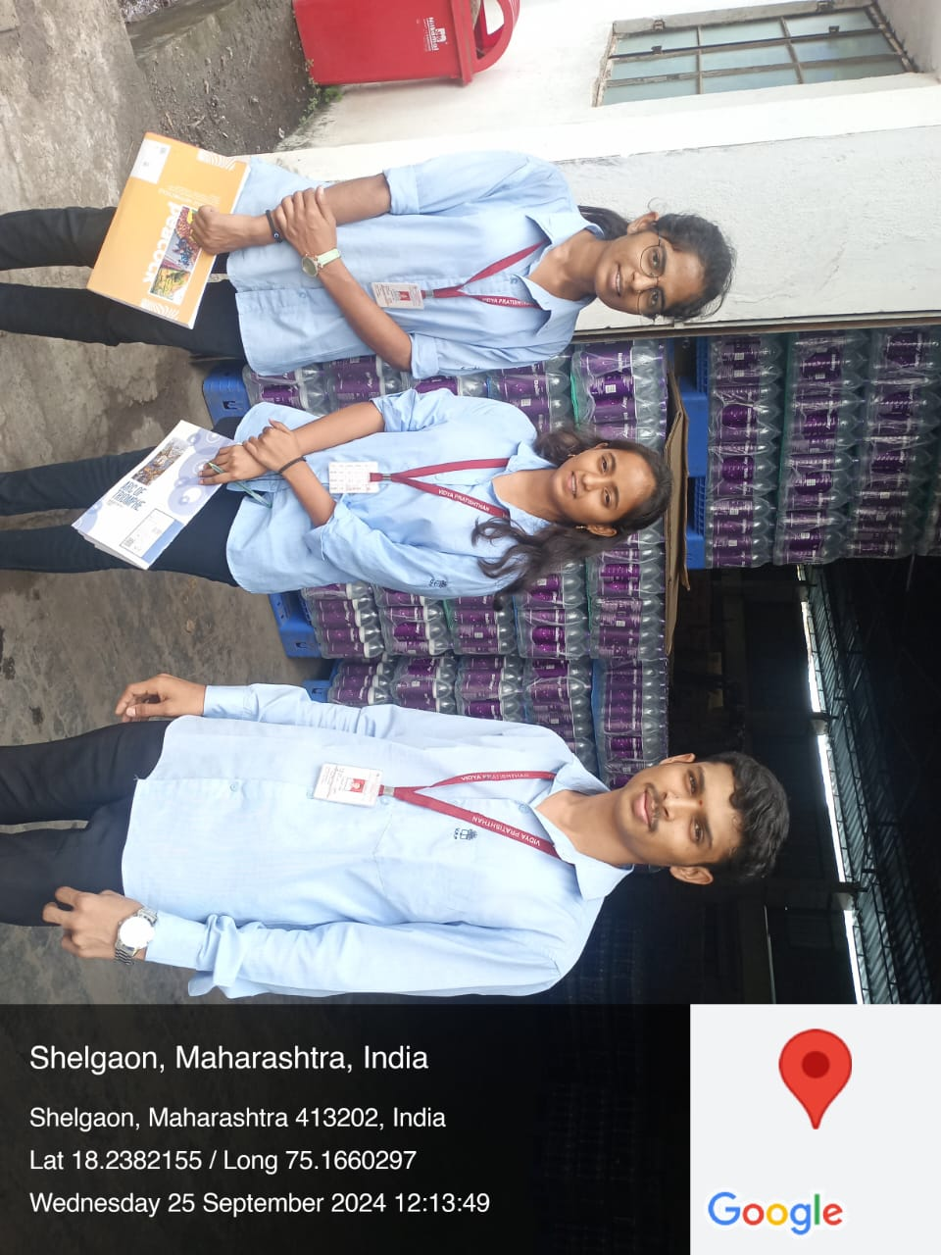

* They explained everything to us from making the bottles to selling the bottles
* After asking a few questions, he learned that the treated wastewater from his company is recycled and used for agriculture as well as for the garden and washing.
* They also encourages its customers to keep water bottles away from direct sunlight and observe its expiration date.
* If not, microplastics can end up in water and become harmful, causing diseases like cancer
* Along with that, the pH of the field where the waste water is discharged was checked and it was found that the pH value of the soil is between 7.0 - 8.0, which indicates that the soil fertility is not very well.

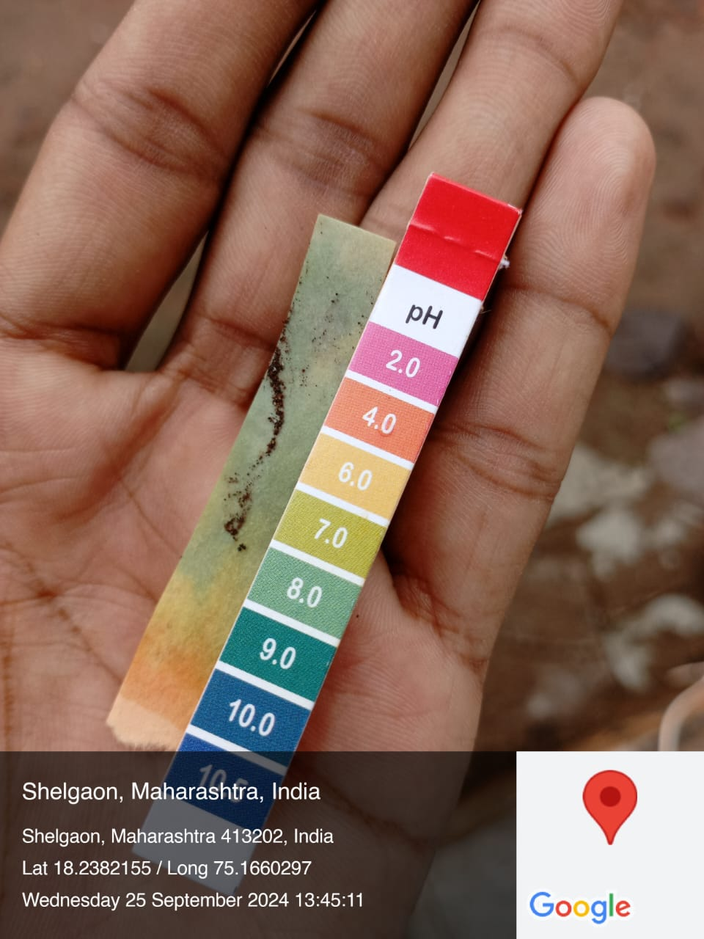

* Also, this company is far from human habitation and this company is spread over 2 acres of land
* He also said that the recycle symbol and the number in the triangle on the bottom side of the plastic bottle indicate the type of plastic and how much time the plastic can be recycled.



* Along with that it was found that water purification is crucial because it has a director impact on both public health and on environment.
* During the monsoon, the rainwater gets mixed with the local water source like wells, lakes, rivers, along with some harmful or bad elements around it. Drinking such water is harmful to the body.So drinking water should be taken after purification process
* In this way, the bad water that comes out of the purification process of this company is reused for agriculture and also for cleaning there. Similarly, the water used in our daily life should be reused, it will be beneficial in the future.